Drivers Education Pre-test
- At what age may you receive an instruction permit if you are enrolled in an approved drivers education class.
  - 17
  - 18
  - 15
  - 14
- You may use a drivers permit when an adult instructor is sitting beside you, with one of your parents or legal guardian or
  - An adult 21 years or older with 1 year driving experience
  - A person 18 years or older and 1 year driving
  - A person between the ages of 16 and 17
- If your name changes or an address change, you must notify the secretary of state with in:
  - 5 days
  - 10 days
  - 15 days
  - 20 days
- True or False. It is required in Illinois to have insurance.
  - True
  - False
- True or False. If you wear corrective lenses or contact lenses, you do not need to wear them every time you get behind the wheel
  - True
  - False
- True or False. You may commit 1 moving traffic violation during the driving portion of the test.
  - True
  - False
- True or False. All drivers in Illinois must wear seatbelts
  - True
  - False
- Drivers under the age of 18 are limited to_________ number of passengers for the first 6 months unless transporting immediate family.
  - 2
  - 3
  - 1
- True or False. A child under the age of 8 must be secured by an approved child restraint system
  - True
  - False
- The maximum speed limit in Illinois is ?
  - 55mph
  - 65mph
  - 75mph
- In school zones, the speed limit is?
  - 15mph
  - 20mph
  - 25mph
- To yield means a driver:
  - Speeds up
  - Gives the right of way
  - Takes the right of way
- When a police or emergency vehicle are using sirens or flashing lights, the driver must pull to the __________ side of the road and stop if necessary.
  - Left
  - Right
  - Center
- True or False: During a funeral procession, cars following the lead car may follow the lead car after cautiously crossing without stopping.
  - True
  - False
- Headlights are required to be on when:
  - Dusk to dawn
  - Windshield wipers are needed
  - Poor visibility
  - All the above
- The following picture represents what type of lane marking
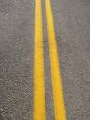
  - Passing allowed
  - No passing zone
  - Passing only on the right

- The white line pictured below represents?
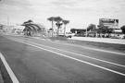
  - Passing Zone
  - Passing on the right
  - Shoulder marking
- True or False. You may pass a stopped school bus when its lights are flashing
  - True
  - False
- True or False. You may park in reserved handicapped spots if you have a place card or plate even if the person who was issued the permit is not present
  - True
  - False
- All vehicles are required to stop within how many feet of the nearest rail of a railroad crossing when a train is approaching.
  - Between 15 and 50 feet
  - Between 5 and 10 feet
  - 10 feet
- It is permissible to pass on a two lane, two way road way within 100 feet of an intersection or railroad crossing.
  - True
  - False
- If your car begins to hydroplane you should:
  - Speed up
  - Brake hard
  - Let off the accelerator
- As a vehicle speed increases, stopping distance:
  - Increases
  - Decreases
  - Is not affected
- It is permissible to make a right hand turn against a red signal light after stopping and yielding to other vehicles and pedestrians.
  - True
  - False

- What should drivers do when approaching a construction area?
  - Increase their speed to get out of the way
  - Slow down and yield the right of way
  - Honk their horn several times to alert individuals working in the area of presence.
- In construction zones and school zones ( when children are present) it is permissible to use a cell phone.
  - True
  - False
- Unless authorized to do so, drivers may break into the line of a funeral procession.
  - True
  - False

- What is the penalty for being convicted of illegally passing a stopped school bus?
  - 3 month suspension of driving privileges and $150 fine
  - 60 day suspension of driving privilege
  - $30 fine and 14 day suspension of driving privilege
- Slow vehicles should use the right hand lane except when passing or making a left turn.
  - True
  - False
- A green sign on a highway tells the driver:
  - Upcoming park or recreation area
  - Distance ,direction, destination
  - Tells the driver about services along the road way
- When a driver approaches an intersection where the traffic signals are not working, the driver should:
  - Come to a complete stop and yield the right of way before entering the intersection
  - If the intersection is clear the driver does not need to stop
  - Drive quickly through the intersection to get out of the way of other vehicles
- If a police officer is at an intersection directing traffic, a driver does not need to obey the officer, only the traffic signals.
  - True
  - False
- The color yellow is used for which type of sign?
  - Construction
  - Regulatory
  - Warning
- The legal alcohol limit for drivers under the age of 21 is .08%
  - True
  - False
- Implied consent law means:
  - You have the right to drive on Illinois roadways
  - You automatically consent to certain test following an arrest for DUI
- Regardless of fault, a crash report must be filed by the driver of a vehicle if the crash involves death, bodily injury or property damage over $500
  - True
  - False
- Motorcycles have the same rights and responsibilities as other roadway users
  - True
  - False
- Bridges may be more dangerous in winter because:
  - The surface heats up faster
  - Ice forms on bridges quicker
  - None of the above
- When driving in adverse weather conditions (fog,rain,snow),what type of headlights should be used?
  - High beam lights ( to see farther ahead)
  - Low beam( so water particles do not reflect light back to the driver)
- When signaling to make a turn in a business district or residential are, a signal must be continuously on for:
  - 25 feet
  - 50 feet
  - 100 feet

Match the sign with the correct meaning
41.Stop sign  AB | A.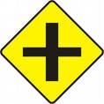
42.No passing Zone  AE | B.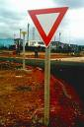
43.Speed limit  AD | C.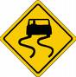
44.Yield  B | D.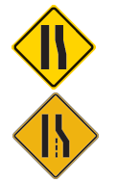
45.Construction zone  AC | AB.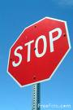
46.Slippery pavement  C | AC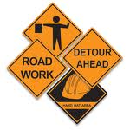
47.Reduction in lanes  D | AD.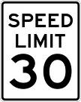
48.Crossroad  A | AE.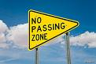
49. Slow moving Vehicle  BD | 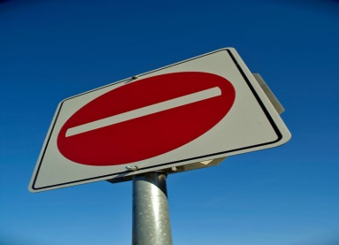  BC
50. Do not enter  BC | 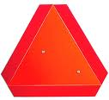  BD

